**Upload Instructions for QTI Question Banks With Images**

Demetrios Pagonis

demetriospagonis@weber.edu

1. Navigate to the “Settings” page of your Canvas course

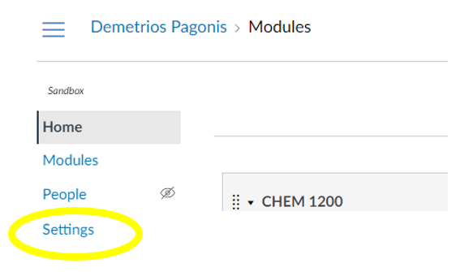

1. Select “Import Course Content” from the left-side menu

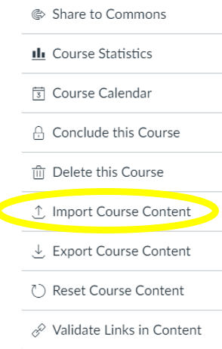

1. Select “QTI .zip file” as the Content Type:

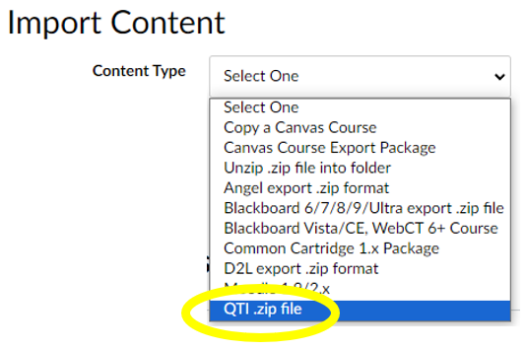

1. Select the file to upload from your computer as the “Source”

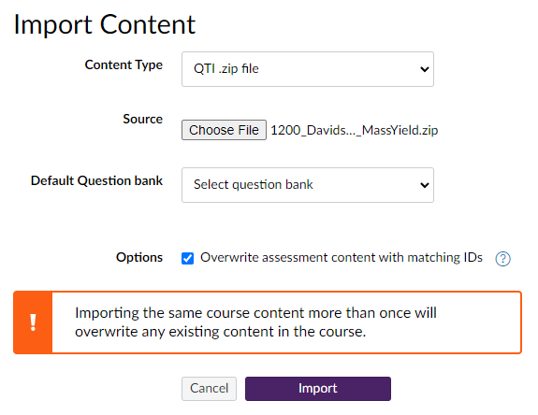

1. Leave the “Default Question bank” option unchanged
2. Select the “Overwrite assessment content with matching IDs” option.
   1. *If you leave this unchecked you will end up with multiple banks with the same name*
3. Press “Import”
4. While the bank is processing, navigate to the “Files” page of your course

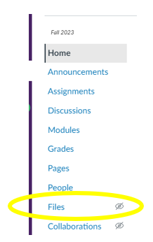

1. If you do not have an “Uploaded Media” folder in this course, create it by pressing the “+ Folder” button
   1. Be certain to match case and have a single space between words

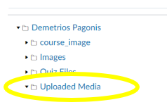

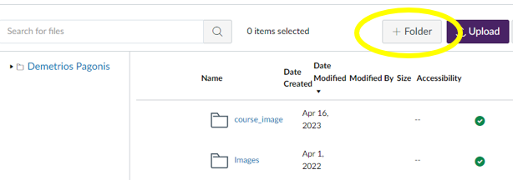

1. Add all the image files for the bank to the Uploaded Media folder.
   1. Note that you should be placing the image files directly into Uploaded Media
   2. If you were sent a .zip file of images you will need to extract them first so that you can upload them to the Uploaded Media folder
2. Once the bank is finished processing it will appear in your list of banks while building quizzes.